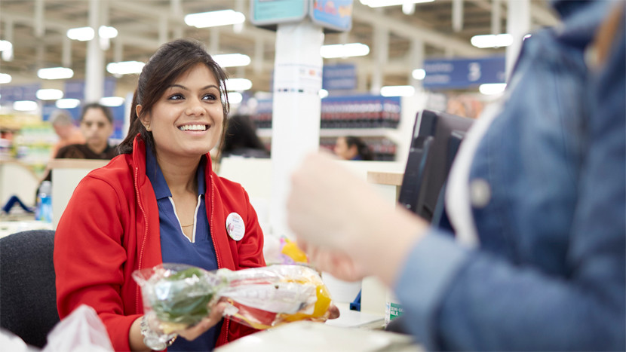
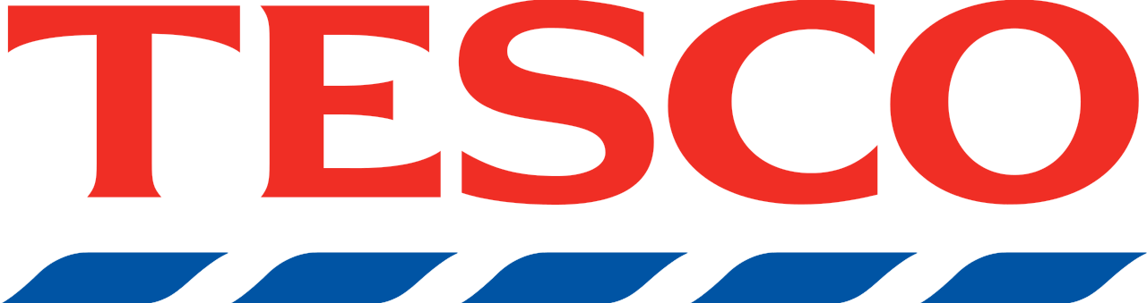
A PRESTCOM and SWOT Analysis of Tesco UK

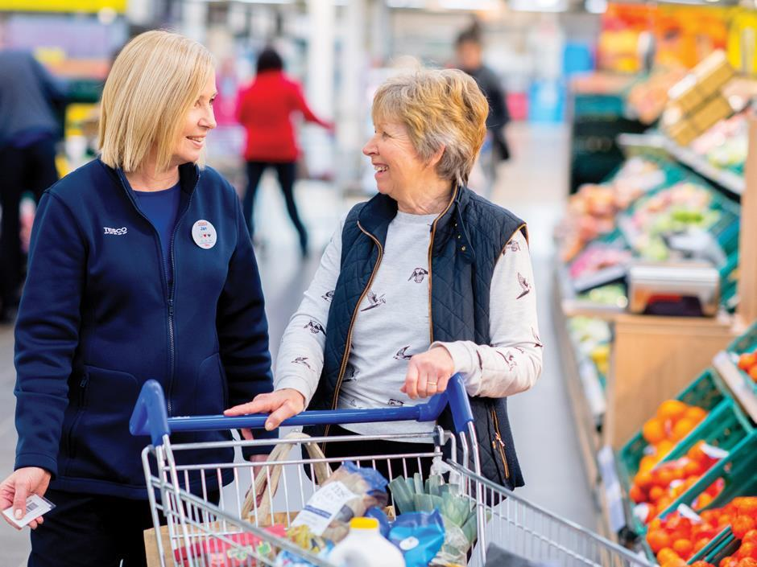
Executive Summary.

The purpose of this report is to see if Tesco UK as a business if feasible by examining all factors that affect its failure or success. Numerous factors decide and affect an organizational environment which should be recognised, grasped and analysed by the business in order to achieve the best performance. This report has been divided into several sections.
Firstly, a PRESTCOM analysis has been carried out on Tesco UK to obtains the factors that affect its organizational environment. Through the use of secondary research, the report not only highlights trends and factors affecting Tesco, but a full analysis of their current market situation.
The second section of the report presents an effective approach to dealing with the strength and weaknesses in Tesco’s environment, that offers opportunities and pose threats. Followed by the understanding of what the company can gain when opportunities meet strengths and weakness meet threats.
The report not only highlights how Tesco UK can develop further, but gives an insight into the business, accompanied by list of strategies that Tesco can execute to better their business.

Table of Contents.

- Introduction………………………………………………………………………… 4
- An analysis of the Marketing Environment Using PRESTCOM and SWOT applied to Tesco UK…………………………………………………………………………. 4
  - PRESTCOM………………………………………………………………... 4
    - Political………………………………………………………….. 4-5
    - Regulatory………………………………………………………. 5
    - Economic………………………………………………………... 6
    - Social……………………………………………………………. 6-7
    - Technology………………………………………………………. 7
    - Competitors……………………………………………………... 7-8
    - Organisation…………………………………………………….. 8-9
    - Market.……………………………………………………….…. 9-10
- SWOT………………………………………………………………………………. 10
  - Ranking…………………………………………………………………….. 10-11
  - Matching……………………………………………………………………. 11
- Conclusion…………………………………………………………………………... 12
- Appendix…………………………………………………………………………….13-14
- Reference…………………………………………………………………………… 15-18

- Introduction.
In light of Tesco UK’s continuous decline in profit from 2013, an analysis of the marketing environment will be conducted on their behalf. This report will not only include the importance and advantages of conducting a market analysis, but would also include a detailed use of PRESTCOM and SWOT analysis framework, with each section applied on Tesco UK. Keeping in mind ‘‘general business principles say that a company should have information about its markets and competition when developing a business, sales, marketing, or growth strategy’’ (France, 2013). It is safe to say that by scanning the environmental market, it would provide a deeper understanding of the market as well as their competition and how to go ahead of it. ‘‘Marketing research can make its greatest contribution to management when the researcher understands the environment, industry, company, management goals and styles, and decision processes that give rise to the need for information’’ (Stevens et al, 2005). It is in Tesco UK’s interest that they conduct an analysis of their marketing environment because it allows for an overview of the whole marketing environment. This then enables management to focus on the decisions to be made. According to Stevens et al (2005: 3) ‘‘A problem or opportunity is the focus of management efforts to maintain or restore performance’’. In Tesco UK’s case they aim to restore performance and it can only be done when the problem or opportunity is recognized, bearing in mind that a problem can be an opportunity.

2.0 An analysis of the Marketing Environment using PRESTCOM and SWOT applied to Tesco UK.

The main key factors that would slow down Tesco’s market would be shown in this PRESTCOM analysis in relation to the competitors, in order to gain market intelligence and improve their brand. The full information is available in the appendix.

2.1 PRESTCOM.

2.1.1 Political.
Tesco UK is vulnerable to a variety of political factors. With Brexit underway with less than a month until the deadline on October 31. Tesco along with other supermarkets within the UK will be affected in terms of trade. In Britain, “almost 30% of our food currently comes from the EU’’ (BBC, 2019). Due to the collapse in value of the British pound against the dollar and Euro, importation of food in the UK would be more expensive. Consequently, “the British worked up an appetite as they voted to leave the European Union’’ (Purdy, 2016). This puts Britain in a tight situation because it imports a lot of its food from the EU. The government’s Operation Yellow hammer documents predict reduced supplies of certain fresh foods, causing price rises that would affect the most vulnerable’’ (Farrel, 2019). Tesco CEO Dave Lewis raises concern and says it is due to possible deal of Britain leaving the EU. ‘‘Crashing out of the EU would create problems for Tesco because it would introduce a hard border between the UK and its neighbours’’ (Farrel, 2019). However, the change in government will not only affect trade but employment wages, as it could rise or fall.

figure.1.0 Origin of food consumed in the UK (2014)
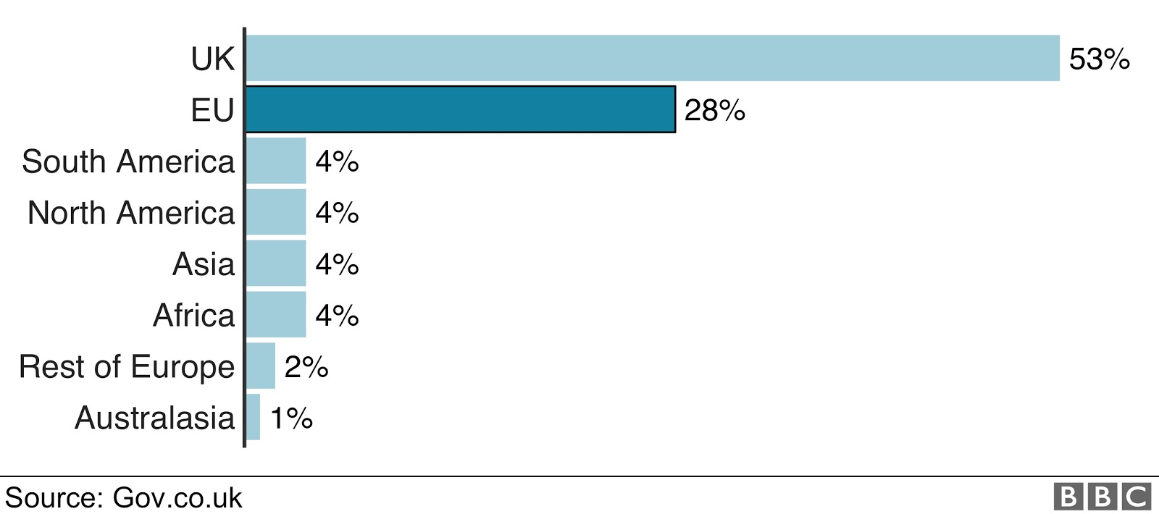
(BBC, 2019)

2.1.2 Regulatory.
‘‘The government is to consult on making regulators independent of representative bodies as part of moves to boost competition in legal services’’ (Hyde, 2015). This new standard of regulations that would come into action in November 2020, acts as part of a ploy to boost the competition in legal service between solicitors. With the use of HM Treasury (2015) policy document, it creates a ‘‘fairer, more balanced regulatory regime for England and Wales’’. Rose (2019) states the new law as significant, as it is ‘‘providing the freedom to allow solicitors to deliver non-reserved legal services to the public from unregulated businesses’’. Evidently, this would not only affect will - writing businesses, but HR and employment advisory firms and most especially Tesco or other retailers. Dakers (2014) states that ‘‘the measures will make it easier for companies to open one-stop shops for legal advice and other services such as accountancy under a multi-disciplinary Alternative Business Structure licence’’.

2.1.3 Economic.
For Tesco, these factors are the main point of focus because they affect cost, demand, profits and prices. ‘‘All firms are affected by the macro-economic environment’’ (Masterson et al 2017). Consequently, PESTLE Analysis (2019) says ‘‘the company should be aware of any changes in policies, such as changes in taxation or any other factors which could affect the accessibility of finance’’. Recently, ‘‘Tesco UK had to make a cut of 4,500 jobs across 153 metro stores’’ (Davis, 2019), as a way to run the business more sustainably. Tesco metro which was originally designed for larger, weekly shops, attracts 70% of consumers who use the opportunity for convenience and grocery shopping. With a change of cutting 34000 Tesco employees, it would cause faster and simpler ways of stocking shelves, staff working more flexibly around stores and a leaner management structure. However, this is a response to the evolving retail environment and wider cost-cutting plan which Tesco tackles by inclusively ‘‘raising prices on 1000 products’’ (BBC, 2019), ‘‘profit jumps in uncertain markets’’ (BBC, 2019) and ‘‘food counter cuts in 90 of their stores hitting 9000 jobs’’ (Blake, 2019). It is possible to say that they plan on retaining profit despite their competition becoming stronger. ‘‘Tesco is in the midst of trying to save £1.5bn as the competition between supermarkets intensifies’’ (BBC, 2019). This may affect Tesco negativity as loyal customers could deflect to cheaper stores just to get away from the product inflation.
2.1.4 Social. ‘‘Consumer shopping trends are constantly changing’’ (Farooq, 2018). Due to the variation in social changes, trends show that one-stop shopping and bulk shopping are what consumers in the UK move towards the most as. ‘‘Britain will have noticed enticing offers to buy more and get a lower price rather than purchasing that item individually’’ (Kaarenperk-vanatoa, 2019). They would also notice the reward system that Tesco gives out with the use of their Clubcard’s as an incentive of collecting points for every £1 purchase on certain products and using the points to get benefits. PESTLE Analysis (2019) argues that ‘‘the type of goods and services demanded by consumers is most influenced by their beliefs and attitudes, which in turn, are influenced by social conditioning.’’ (It is safe to say Tesco depends on their UK consumers and only through understanding the social conditions can they provide the services to counter them.

figure 2.0 Attitudes towards and usage of selected brands
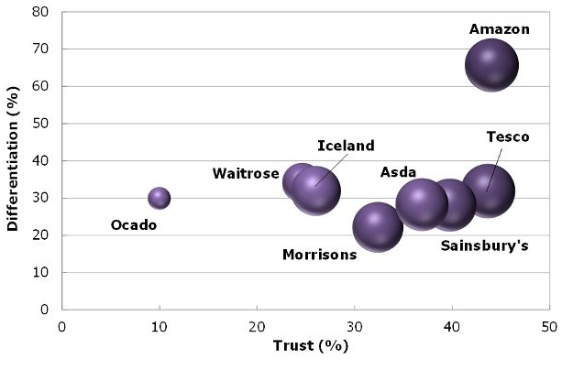
(Mintel, 2019)

2.1.5 Technological.
The importation of new technology into a business is an advantage for not only customers, but the organization as it makes the experience more convenient and seamless. Technology advancements has become very resourceful for Tesco as it has brought different opportunities, as well as ‘‘improved customer satisfaction’’ (Newman, 2018). With the incorporation of new technology such as Tesco’s online store and Tesco’s ‘Shop and go’ app, which is ‘‘technology that allows customers to scan and pay for their groceries on their smartphone and then walk out of the store without visiting a till’’ (Wood, 2018), means Britain's first cashless store. “We want to make it as easy as possible for customers to shop with us” (Tesco, 2016), so customers are able to save time at the checkout and they “track their spend as they go” (Quinn, 2016).

2.1.6 Competitors.
‘‘The retail supermarket industry is very competitive in the UK, with 10 different brands fighting for market share’’ (BBC, 2017). Its main competitors being ASDA, Sainsbury’s and Morrisons, which are often referred to as the Big Four in the United Kingdom, means a saturated market. Although, Downie (2018) says ‘‘German grocers Aldi and Lidl have also become strong competitors in the U.K. grocery market’’. ‘‘Tesco does have an advantage in the retail supermarket sector and experienced growth from its Tesco Extra stores” (Kantar Worldpanel, 2018). “The selection of groceries on offer has made customers come with fuller trolley shops” (McKevitt, 2018).

Figure 3.0 Great Britain grocery Market Share
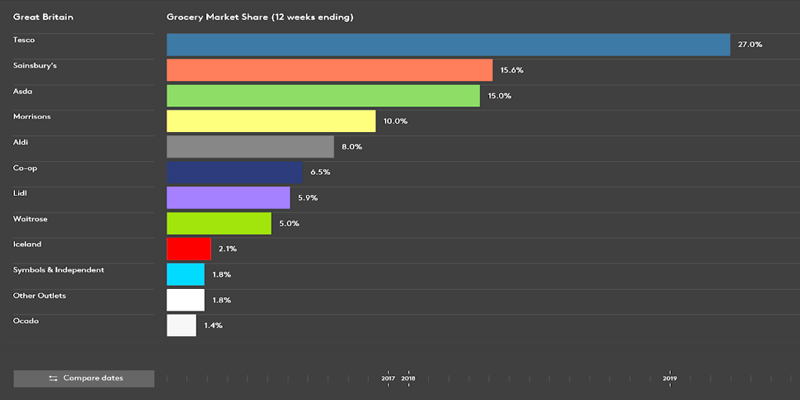 (Kantar, 2019)

2.1.7 Organization.
Tesco as a brand is perceived as a “modern brand grocer” (Tesco, 2018), as well as a British icon. In 2002, the second largest convenience store T&S was purchased by Tesco, in a £377.3 million deal. No other supermarket has done a deal this big before. However, this is because they aim to ‘‘increase its presence in many neighbourhoods across the country’’ (Tran, 2002), even though Tesco depends mostly on their UK stores. With this purchase Tesco will be able to busters their shares of a growing market.

Figure 4.0 number of Tesco stores worldwide
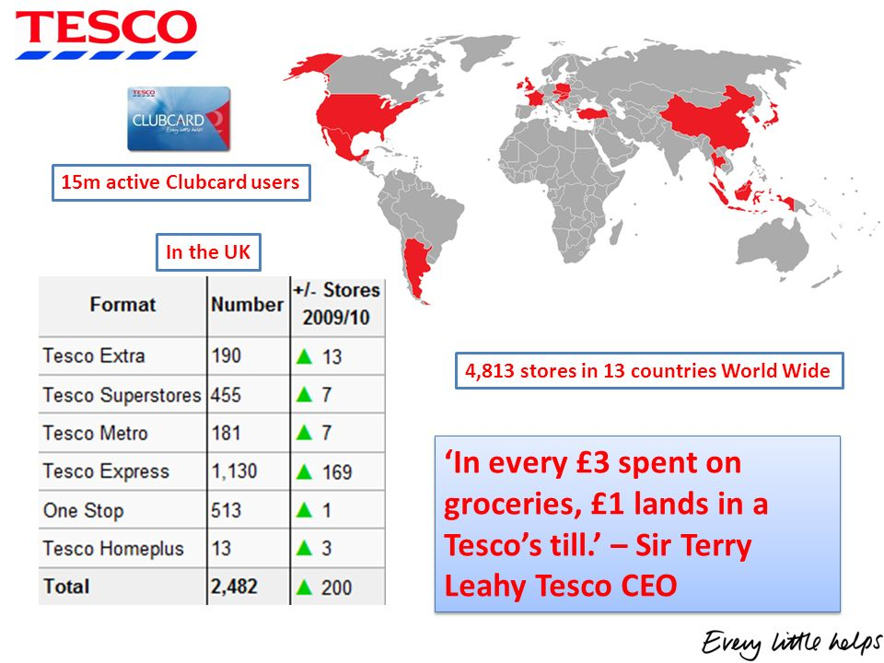
(Clark,2019)
2.1.8 Market.
According to the Office for National Statistics (2019), “supermarkets have seen an increase of sales of 3.9% from the previous year”. With Tesco in particular experiencing an impressive growth over the years, “with a 2.3% increase in sales in 2018” (Tesco Plc, 2018). Although, Tesco market share is increasing, it is nowhere near its peak of 32% in October. ‘‘At its peak, in October 2007, Tesco's share hit 31.8%’’ (Wood, 2014). ‘‘The good weather over the summer helped to continue trends, however, growth has slowed since September as weaker demand began to hit the supermarkets’’ (Mintel, 2018). Due to the extended hot weather that the UK has endured over the summer holidays, ‘‘Mintel is forecasting further growth’’ (Mintel, 2018). With more consumers wanting to eat healthier, Tesco partnership with WWF helps cater to consumers who want to eat healthier for less. This “is ground-breaking as it will make customers buy affordable, healthy, sustainable food” (Tesco, 2018), with the aim of ‘‘reducing the environmental impact of the average UK shopping basket by 50%” (Tesco Plc, 2019). This will make Tesco’s market share grow as more people will want more healthy food for a low price.

Figure 5.0 Annual non-seasonally adjusted percentage change in the value sales of food retailers at current prices
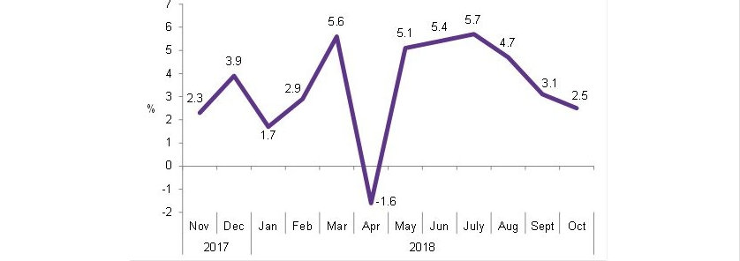

(Mintel, 2018)

3.0 Swot Analysis.
There are many factors that affect Tesco’s market in the UK. The following are the key strength, weakness, opportunities and threats of Tesco as identified in the PRESTCOM above.

3.1 Ranking.
Strengths Ranked.  - Leading market share - currently at 28.4%  - Reward system increases the number of customers  - competitive pricing of products  - Geographically diverse - with 65% of its selling space outside the UK.  - Growing number of stores  - Victorious diversification strategy - Well liked clothing range F&F, Tesco mobile, Financial and telecom service, Tesco legal advice.  - Trustworthy and credible brand  - Usage of high-level technology  - Largest private employer in Europe.  - Good online presence  - Tesco’s Jack's business expansion | Weakness Ranked.  - Failed operations outside the UK - US and Japan.  - Loss of money due to fraud charges and scandals.  - Operating profits decline - share prices fell 9% by 2018  - Even though market share is increasing, market share is nowhere near the peak of 32%  - Relies mostly of UK based stores.  - Tesco’s Jack's business expansion
Opportunities Ranked.  - Tesco’s Jack's business expansion  - Increase in health and fitness demands  - Alliances with other brands- e.g. partnership with WWF  - Growing Online business  - Expanding more outside the UK where the market is growing  - More diversification strategies.  - More demand for sustainable food  - Tesco’s Jack's business expansion | Threats Ranked.  - A possible Brexit referendum - Competing with giant supermarkets in the UK  - competition with low cost rivals such and Aldi and Lidl.  - Most likely other stores becoming cheaper to keep up with market trends.  - Saturated Market  - Tesco’s Jack's business expansion
3.2 Matching. The following is the comparison of the SWOT above to develop core competence of the business as well as strategic positioning in the marketplace and gaining competitive advantage.
Similarities Matched with Opportunities.  1. Due to Tesco’s credibility there should be more development and growth of the brand in expanding foreign markets where Tesco has no presence in yet. (Africa, Australia, Russia, India) (S8, S6, O5)  2. Build on customers demand to be healthier and fitter by using Tesco’s online presence to generate an online chatroom in order to connect with their vegan and health enthusiastic customers more intimately through. With the use of online communication between them and Tesco nutritionist and health advisors. This could be a way of getting professional support and help through the customers fitness journey. (S11, O2, O4)  3. Clubcard’s specific for Jack’s stores as an incentive to attract more customers with the same point reward system Tesco implements for certain products. (S3, O1) | Weaknesses Matched with Threats.  1. Tesco relies on mostly on their UK based stores. However, the UK market is already saturated with other retailers competing for leading market share. Together with the uncertainty of Brexit, Tesco’s future looks difficult unless they build revenue outside the UK market. (W6, T1)  2. Although Jack’s low pricing helps to disables Tesco’s market, they compete with Aldi and Lidl instead. Aldi and Lidl would have no choice but to lower their prices to compete with Jack’s. (W7, T2)  3. Tesco tarnished brand imagine from fraud charges and scandals could cause the Serious Fraud Office to look into Jack’s accounts unless it learns from Tesco’s mistakes and special attention is applied to every aspect of the Jack’s stores. (W2, T5)

4.0 Conclusion.
With Tesco being part of a larger environmental market, the analysis above shows several ways and points at which the competition has influenced Tesco’s market. From the use of PRESTCOM and SWOT analysis on Tesco supermarket, point emerge from across the entire business. Traditional competitors such as Sainsburys and Lidl pose major threats for Tesco due to their offer of cheaper products. Not to mention demand on sustainable, healthier food and the uncertainty of Brexit are putting pressure on Tesco. Nevertheless, Tesco improve its sales through building on its emerging opportunities and strengths, while the weaknesses and threats are minimized to the lowest level in order to handle the challenges that come with a saturated market and the EU referendum.

5.0 Appendix.
Regulatory | Although not a lot of supermarkets have been given the licence. Tesco’s competitor Co-op has grown in its legal service since 2006 and in ‘‘2012 Becomes first Alternative Business Structure, under 2007 Legal Services Act’’ (The Co-operative Legal Services, 2006), causing them to reach market-leading position for probate by 2014. With the goal of retaining their market-leading position, Tesco aims to reflect the results of Co-op with the launch of Tesco law in 2020. Other companies that have tried to host legal services include BT, The AA, Saga and Halifax by offering online legal documentation production. ‘Most companies that have turned to the law so far have done so on a relatively small scale’’ (Dakers, 2014). It is possible to say that Tesco would not rush into implementing the new law, but take its time and gradually expand. Inclusively focusing on oversight, systems, controls and culture as a business in order to avoid legal action being taken on those parts. Rose (2015) expects ‘‘to see an increase in the coming years of regulatory action taken against firms (as opposed to just individual solicitors) for the business’s failures of oversight, systems, controls and culture’’.
Economic | ‘‘It comes as German budget rivals Aldi and Lidl continue to put pressure on the big four supermarkets’’ (BBC, 2019). Certainly, the pressure is put on Tesco because of how their German rivals aim on selling quality products for way less money than Tesco. This attracts more customers, but adds to the pressure Tesco faces to retain the same budget of £1.5bn. As a response they opened a discount chain Jack’s, an extension of Tesco UK, that’s acts as competitions for the German rivals without diminishing Tesco’s profit margins. ‘‘It seems likely that Britain's biggest supermarket group is looking to more decisively compete with rapidly expanding German discounters Aldi and Lidl’’ (Barrie, 2018). Although this would help get more consumers for Tesco, the different brandings could confuse the consumers in a way that makes Jack’s customers rivals for Tesco. People would prefer to go for the generically cheaper brand and that might make Jack’s profit to rise and Tesco profits to reduce, even if it is a branch of Tesco.
Social | Due to the fact that perishable items get spoilt easily when bought in bulk, Tesco increases the number of non-food items offered for sale, BBC (2006) adds that ‘‘It has expanded into most areas of the retail market, selling clothes, books, electrical goods and seasonal items such as barbecues and garden furniture’’. Another issue society and consumers are more concerned about is obesity. ‘‘The rise in obesity, especially childhood obesity, has given rise to significant anti-sugar lobbies in Western countries’’ (Masterson et al 2017). Due to more awareness when it comes to food by customers, Tesco approaches these issues by accommodating more organic food which would develop closer ties to the customers and create loyal shoppers.
Technological | In addition to customers feeling comfort knowing their items are readily accessible to them, they feel safer as the removal of cash would make 1800 Tesco Express stores less enticing to criminals. Although “There is a significant amount of robberies in Express stores every week’’ (Wood, 2018), less cash would mean less robberies.
Competitive | *With the nearest rivals being Sainsburys and Asda, they threaten to take Tesco’s market share as Aldi and Lidl market share has doubled in 5 years from 6.8% to 13.1%’’ (Kantar Worldpanel, 2018). However, by Tesco opening its own discount store ‘Jacks’ they meet consumer demands and carry on to maintain and grow their market share. Even though Tesco consumer perceptions has affected market share through the horsemeat scandal and fines for misleading prices. So far, ‘‘Tesco has maintained its profit margins by keeping operational costs low’’ (Vizard, 2013).

Reference.

Admin, W. (2012). Tesco: International Marketing Gone Wrong. [online]. Available at:
https://www.wolfestone.co.uk/blog/tesco-international-marketing-gone-wrong/ [accessed 22/10/2019]

Armstrong, A. (2016). Tesco trio to stand trial in September 2017 over fraud charges. The Telegraph. [online]. Available at: https://www.telegraph.co.uk/business/2016/10/20/tesco-trio-to-stand-trial-in-september-2017-over-fraud-charges/ [accessed 22/10/2019]

Baron, O. (2019). Tesco to continue Jack's expansion despite failure of Rawtenstall branch. [online] available at: https://www.lancs.live/whats-on/shopping/tesco-continue-jacks-expansion-despite-17016735 [accessed 22/10/2019]

BBC. (2007) The continued rise of Tesco non-food. BBC. [online]. Available at: http://news.bbc.co.uk/1/hi/business/6257331.stm [accessed 22/10/2019]

Barrie, J. (2018). Tesco launching Jack's, a new discount chain to compete with Aldi and Lidl.[online] available at: https://inews.co.uk/news/consumer/jacks-tesco-new-discount-store-when-open-lidl-aldi-507465 [accessed 27/11/2019]

Blake, I. (2019). Tesco to cut 9,000 jobs and close fish, meat and deli counters in 90 stores. The Sun. [online] Available at: https://www.thesun.co.uk/money/8298476/tesco-cutting-9000-jobs-close-fish-meat-deli-counters/ [accessed 27/11/2019]

BB. (2006). The continued rise of Tesco non-food. BBC. [online] available at: http://news.bbc.co.uk/1/hi/business/6257331.stm. [accessed 27/11/2019]
BBC. (2017). Tesco says turnaround is on track as sales rise again. BBC. [online] available at: https://www.bbc.co.uk/news/business-41495322 [accessed 27/11/2019]

BBC. (2019). Tesco raises prices on 1,000 products. BBC. [online]. Available at: https://www.bbc.co.uk/news/business-49048822 [accessed 27/11/2019]

CC. (2016). Tesco: A digital transformation. [online] Available at: https://digital.hbs.edu/platform-rctom/submission/tesco-a-digital-transformation/ [accessed 22/10/2019]
CO-OP Legal service. (2016) available at: https://www.co-oplegalservices.co.uk/about-us/ [accessed 27/11/2019

Dakers, M. (2014). 'Tesco Law' rules relaxed to encourage more one-stop law shops. The Telegraph. [online] available at: https://www.telegraph.co.uk/finance/newsbysector/supportservices/11187121/Tesco-Law-rules-relaxed-to-encourage-more-one-stop-law-shops.html [accessed 27/11/2019]

Davies, R. (2019). Tesco to cut 4,500 jobs at 153 UK outlets in latest redundancies. The Guardian. [online] available at: https://www.theguardian.com/business/2019/aug/05/tesco-cut-jobs-latest-redundancies-counter-staff [accessed 27/11/2019]

Downie, R. (2018). Who Are Tesco's Main Competitors? [online] available at: https://www.investopedia.com/articles/markets/092315/who-are-tescos-main-competitors.asp [accessed 27/11/2019]
Eley, J. (2018). Tesco shares fall after operating profits disappoint. [online]. Available at: https://www.ft.com/content/a0863b1c-c6d0-11e8-ba8f-ee390057b8c9 [accessed 22/10/2019]

Farooq, U. (2018) PESTLE Analysis of Tesco. [online] available at: https://www.marketingtutor.net/tesco-pestle-analysis/ [accessed 27/11/2019]

Farrell, S. (2019). Tesco has it tough enough already without a no-deal Brexit. The guardian. [online] available at: https://www.theguardian.com/business/2019/sep/28/tesco-no-deal-brexit-supermarkets-hard-border-uk-eu [accessed 27/11/2019]

France, Charles E. (2013). Marketing Strategy for Small- to Medium-Sized Manufacturers: A Practical Guide for Generating Growth, Profit, and Sales, Business Expert Press, ProQuest Ebook, http://ebookcentral.proquest.com/lib/dmu/detail.action?docID=1192391
[accessed 2019-10-22 06:20:52]
HM Treasury. (2015). A better deal: boosting competition to bring down bills for families and firms. [online] pg. 12. available at: https://assets.publishing.service.gov.uk/government/uploads/system/uploads/attachment_data/file/480798/a_better_deal_for_families_and_firms_web.pdf [accessed 27/11/2019]

Hyde, J. (2015). Treasury’s regulation shakeup herald’s new era for ‘Tesco law’. The Law Society Gazette. [online] available at: https://www.lawgazette.co.uk/news/treasurys-regulation-shakeup-heralds-new-era-for-tesco-law/5052498.article [accessed 27/11/2019]

Kantar. (2019) Grocery Market Share (12 weeks ending). [online] available at: https://www.kantarworldpanel.com/en/grocery-market-share/great-britain/snapshot/03.11.19/06.10.19 [accessed 27/11/2019]

Kaarenperk-vanatoa, K. (2019). Bulk Buying: Does It Really Save You Money In The Long-term?. [online] available at: https://www.peachy.co.uk/blog/bulk-buying/ [accessed 27/11/2019]

Kantar Worldpanel. (2018). Tesco and Morrisons rise to the big four. [online] avalible at https://www.kantarworldpanel.com/global/News/Tesco-and-Morrisons-rise-to-top-the-big-four- [accessed 27/11/2019]
Knox, S. (2012). Tesco's Growth Success. [online]. Available at: https://www.som.cranfield.ac.uk/som/p18725/Think-Cranfield/2012/November-2012/Tesco-s-Growth-Success [accessed 22/10/2019]

Masterson, R., Phillps, N., Pickton, D. (2017) Marketing: An Introduction. 4th edition. London: Sage Publication.

McKevitt, F. (2018) Tesco and Morrisons fastest-growing supermarkets of UK big four. [online] available at: https://uk.kantar.com/consumer/shoppers/2018/march-tesco-and-morrisons-fastest-growing-supermarkets-of-uk-big-four/ [accessed 27/11/2019]

Mintel. (2018) Supermarkets- UK. [online] available at: https://academic.mintel.com/display/931230/?highlight#hit1 [accessed 27/11/2019]

Mintel. (2018). UK retail Briefing. [online] available at: https://academic.mintel.com/display/936208/?highlight [accessed 27/11/2019]

Mintel. (2019). Online Grocery Retailing- UK. [online] available at: https://academic.mintel.com/display/949572/?highlight [accessed 27/11/2019]

Newman, D. (2018) Work smarter: Improve customer satisfaction through technology. [online] available at: https://itbizadvisor.com/2018/02/work-smarter-improve-customer-satisfaction-through-technology/ [accessed 27/11/2019]

Office of National Statistics. (2019). Retail sales, Great Britain. [online] available at: https://www.ons.gov.uk/businessindustryandtrade/retailindustry/bulletins/retailsales/january2019 [accessed 27/11/2019]

PESTLE Analysis. (2019) PESTLE Analysis for Tesco discusses its Business Environment. [online] available at: https://pestleanalysis.com/pestle-analysis-tesco/amp/ [accessed 27/11/2019]

Purdy, C. (2016). The British import a quarter of their food from the EU, and that’s a problem. [online] available at: https://qz.com/716156/the-british-import-a-quarter-of-their-food-from-the-eu-and-thats-a-problem/ [accessed 27/11/2019]
Quinn, Ian. (2016) Tesco's Scan as you Shop service to go into 20 more stores. [online] available at: https://www.thegrocer.co.uk/service-and-availability/tescos-scan-as-you-shop-service-to-go-into-20-more-stores/541531.article

Reading, T. (2013). Can Diversification Power Tesco's Growth? [online]. Available at: https://www.fool.com/investing/international/2013/04/09/can-diversification-power-tescos-growth.aspx [accessed 22/10/2019]

Rose, N. (2019). Tesco Law at last? SRA rules could herald “new breed of MDP”. [online] available at: https://www.legalfutures.co.uk/latest-news/tesco-law-at-last-sra-rules-could-herald-new-breed-of-mdp [accessed 27/11/2019]

Sharpe, Ashley., Bamford, J. (2000). Tesco - How 'Every Little helps' was a big help to Tesco. [online]. Available at: https://www.warc.com/content/article/Tesco__How_Every_Little_helps_was_a_big_help_to_Tesco/27419 [accessed 22/10/2019]

Stevens, Robert E., et al. (2005). The Marketing Research Guide, Routledge. ProQuest Ebook, http://ebookcentral.proquest.com/lib/dmu/detail.action?docID=1046849 [Accessed 2019-10-22 06:41:40]

Symetser, C. (2019). Tesco launch price cuts on hundreds of items in latest Centenary deals event. Mirror, [online]. Available at: https://www.mirror.co.uk/money/shopping-deals/tesco-launch-price-cuts-hundreds-19911406 [accessed 22/10/2019]

Tesco (2016) strategic report. [online] available at: file:///Users/p16228304/Downloads/strategic-report-2016.pdf
Tesco PLC. (2018). Strategic report. [online] available at: https://www.tescoplc.com/media/476557/tesco_2018_strategic_report.pdf [accessed 27/11/2019]

Tesco (2018) annual report and financial statements. [online] available at: https://www.tescoplc.com/media/474793/tesco_ar_2018.pdf [accessed 27/11/2019]

Tesco plc (2018) Tesco and WWF join forces to make food more sustainable. [online] available at: https://www.tescoplc.com/news/2018/tesco-and-wwf-join-forces-to-make-food-more-sustainable/ [accessed 27/11/2019]

Tesco Plc. (2019). Annual Report. [online]. Available at: https://www.tescoplc.com/investors/reports-results-and-presentations/annual-report-2019/ [accessed 22/10/2019]

Tran, M. (2002) Tesco snaps up T&S Stores. The Guardian. [online] available at: https://www.theguardian.com/business/2002/oct/30/tesco [accessed 27/11/2019]

Vizard, S. (2013). ‘Tesco can destroy competition by cutting prices. [online] available at: https://www.marketingweek.com/tesco-can-destroy-competition-by-cutting-prices/ [accessed 27/11/2019]

Wood, Z. (2014). Tesco market share shrinks to lowest level in almost a decade. The Guardian. [online]. Available at: https://www.theguardian.com/business/2014/mar/11/tesco-market-share-shrinks-lowest-level-decade-aldi-supermarket [accessed 22/10/2019]

Wood, Z., Butler, S. (2015). Tesco cuts range by 30% to simplify shopping. The Guardian, [online]. Available at: https://www.theguardian.com/business/2015/jan/30/tesco-cuts-range-products [accessed 22/10/2019]

Wood, Z. (2016). Low prices and no frills: can Tesco’s secret plan defeat Lidl and Aldi? The Guardian. [online]. Available at: https://www.theguardian.com/business/2018/sep/15/low-prices-no-frills-can-tesco-defeat-lidl-and-aldi [accessed 22/10/2019]

Wood, Z. (2018). Tesco trials 'shop and go' app in till-free store. The Guardian. [online] available at: https://www.theguardian.com/business/2018/jun/28/tesco-shop-and-go-app-till-free-store [accessed 27/11/2019]

See figure 1.0
See appendix for further information on Regulatory factors.
See appendix for full information on Economic factors
see figure 2.0
see appendix for full information on Social factors.
See appendix for full information on Technological factors.
See figure 3.0
See appendix for full information on Competitive factors.
see figure 4.0
see figure 5.0
Strength information sourced from: Downie, R. (2018). Wood, Z., Butler, S. (2015). Symetser, C. (2019). Knox, S. (2012). BBC. (2007). Sharpe, Ashley., Bamford, J. (2000). CC. (2016). Tesco Plc. (2019)
Weakness information sourced from: Admin, W. (2012). Armstrong, A. (2016). Eley, J. (2018). Wood, Z. (2016). Wood, Z. (2014).
Opportunity information sourced from: Baron, O. (2019). Tesco, (2018). Tesco, (2016). Tran. (2002). Reading, T. (2013). Tesco (2018).
Threats information sourced from: Farrell. (2019). BBC. (2019). Mintel. (2018). Baron, O. (2019).
see figure 3.0

